LO: I know the seas and rivers of the United Kingdom
In this lesson, we’re learning about the different seas around the UK and some of its major rivers.
For this lesson, you’ll need to use an atlas or map (internet or book) to locate and name ten rivers.
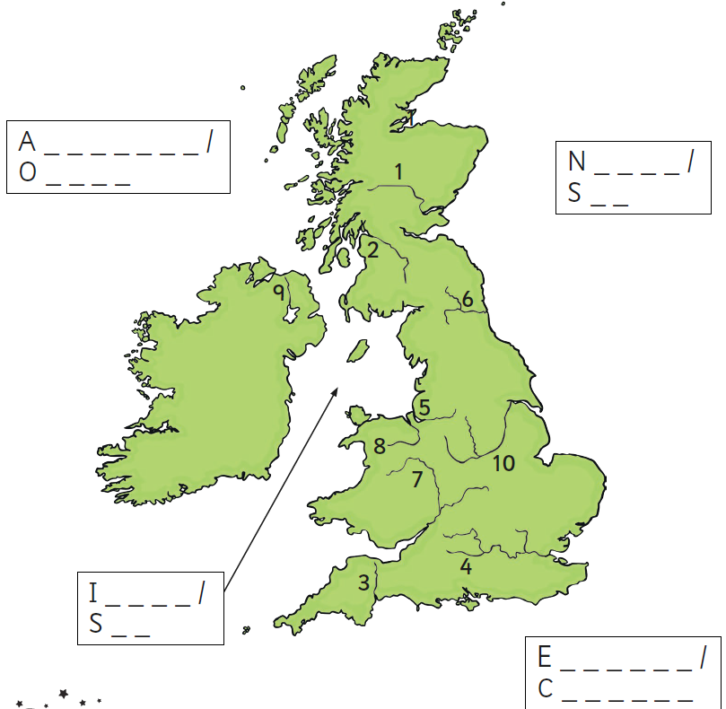

Clues
Here are some clues from the previous lessons on cities and counties to help you.
- The River Clyde is in Scotland, near Glasgow.
- The Thames flows through England’s capital city.
- The Mersey flows through Liverpool.
- The Trent passes next to Nottingham Forest’s football ground.
- The Tyne and Newcastle go together.
- The River Exe flows through Devon.
- The River Severn is the longest river in Great Britain. It is in both Wales and England.
- The River Tay is the longest river in Scotland. It begins in the Scottish Highlands and its mouth is near Dundee.
- The River Dee is found in the north of Wales.
- The River Bann is the longest river in Northern Ireland.

Challenges
- Which river runs through the counties of North Yorkshire, West Yorkshire and the East Riding of Yorkshire? It also flows through Leeds.
- Name and locate two other rivers which run through Yorkshire.

Quiz
The following quiz will test you on rivers in England. Look for the other rivers quizzes on this website as well.
https://lizardpoint.com/geography/england-rivers-lvl1-quiz.php

Day 3: Answers
