**Reading**

This is the first page of a booklet produced by the Heart of England Forest.<https://www.heartofenglandforest.com/tree-guide/>

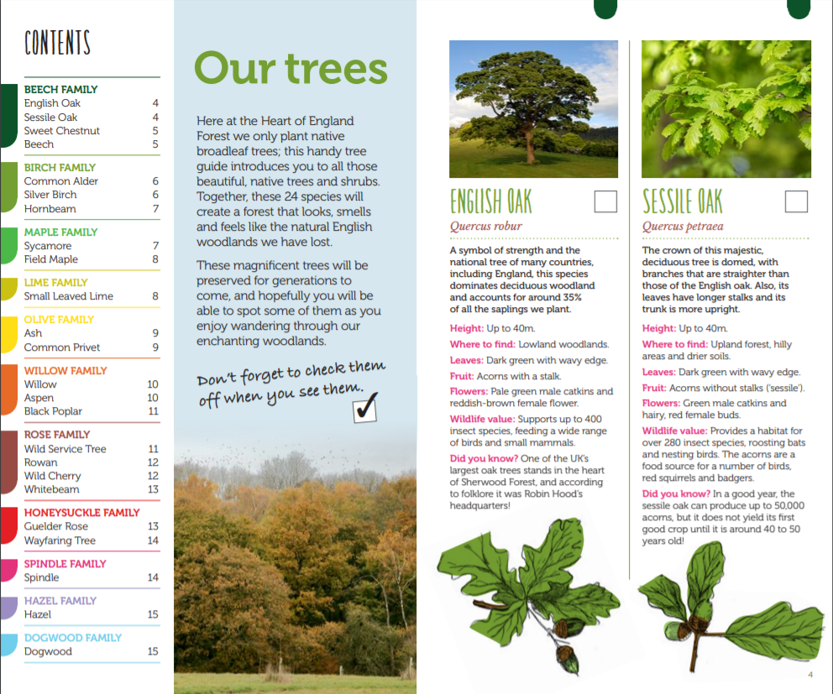

**Glossary**

|  |  |
| --- | --- |
| **word** | **Definition** |
| native tree | A tree that is from a particular place and has not been introduced by people from, for example, another country. |
| deciduous tree | Trees which drop their leaves in autumn. |
| broadleaf trees | All trees which have flat leaves and produces seeds inside of fruit. Almost all deciduous trees are also broadleaf trees. |
| sapling | A young tree. |
| preserved | To keep something in its original state for a long time. |

**Activity**

First, read the text with an adult and talk about it. Look at the glossary I’ve created. Find the glossary words in the text.

Next, answer the following questions about the text:

Read and look at the contents page.

1. Why is the contents page a useful tool?
2. How many trees are in the Birch family?
3. How many different families of trees are there in this book?

Read the section named ***Our Trees***.

1. Choose the statement which describes the section best:
   1. It is a set of instructions.
   2. It introduces you to the text.
   3. It tells a story.
   4. It is a summary about the trees.

Read the sections about the English Oak and the Sessile Oak tree.

1. Which tree can be found in upland forest?
2. What is the difference between the fruit of the two trees?
3. In which forest would you find one of the Uk’s largest oak trees?
4. How many insect species is the sessile oak a home for?

40 400 280 50,000

1. Why do you think there is a small square box next to the name of each tree?

(tip: look at the Our Tree section to help find the answer)