Add these fractions by adding the whole first then the fractions. Give your answer in its simplest form.
1)
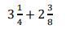
2)
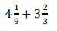
3)
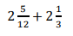

Add these fractions by converting them into improper fractions.
1)
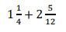
Answers:
- 5 and 5/8
- 7 and 7/9
- 4 and ¾
- 44/12
- 31/9
- 29/6
- 6 and 10/9
- 4 and 1/6
- 4 and 1/8
2)
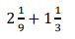
3)
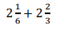
Challenge:
1)
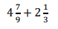
2)
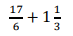
3)
