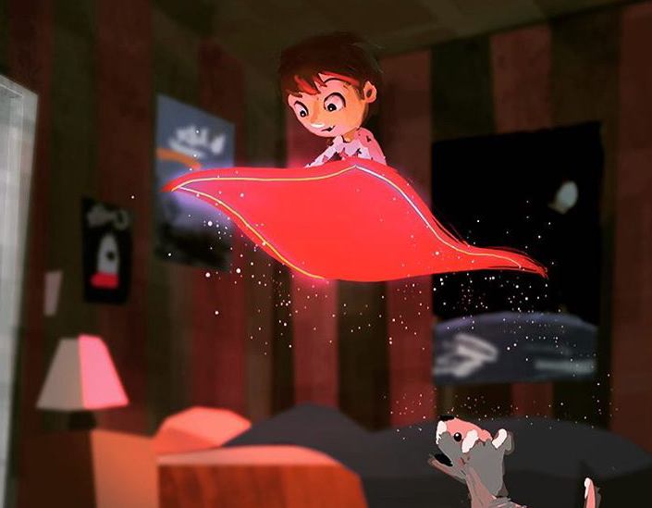

What is happening here?

Why/how is the carpet floating?

How is the boy feeling? Was he expecting this to happen?

How is the dog feeling? How do you know?

Does this bedroom belong to the boy? What does the setting tell you about his character?