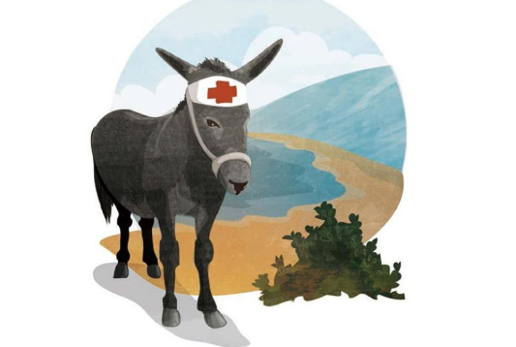
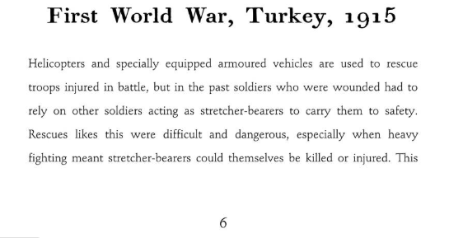

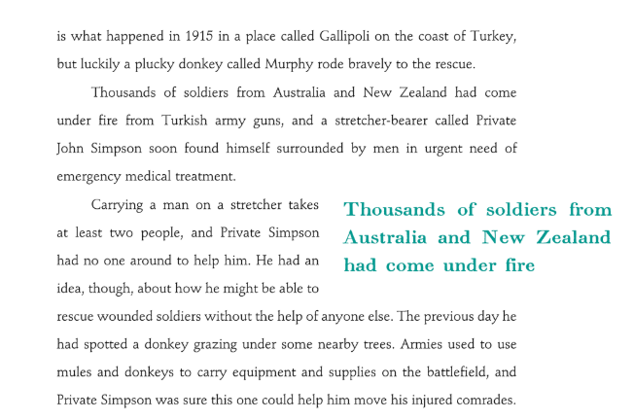

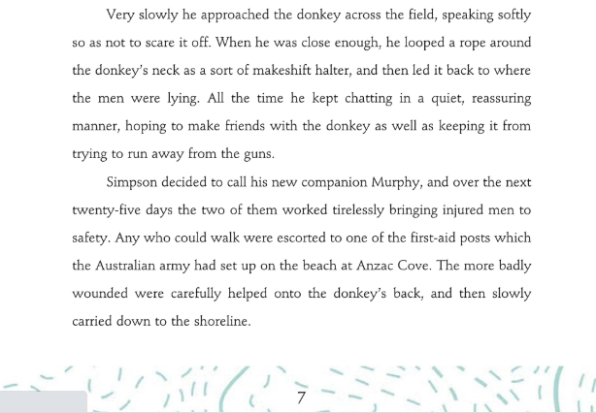

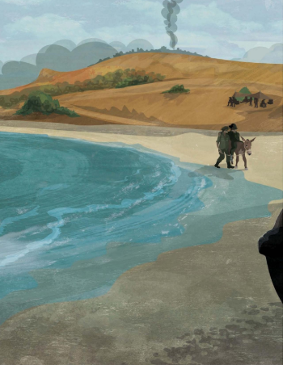

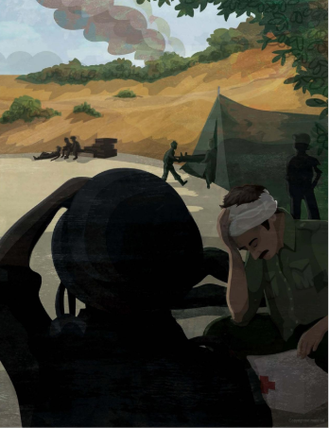

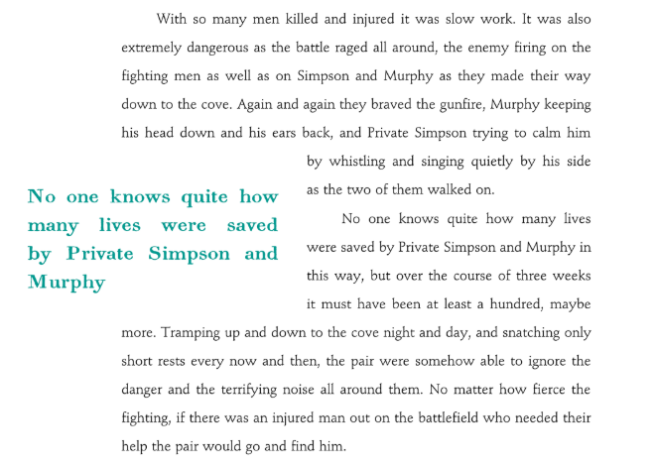

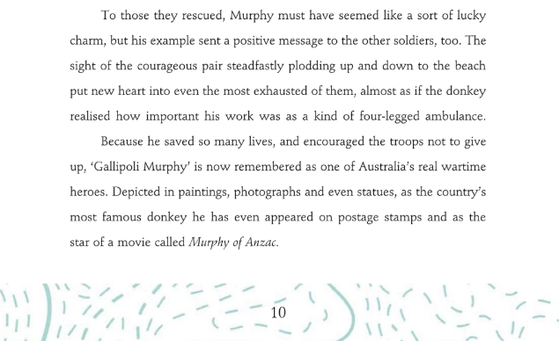

Fact or opinion? Sort these statements in your home learning book.

- The badly wounded soldiers, who could not walk, were carefully helped onto Murphy’s back and then slowly carried down the shoreline.
- To the soldiers, Murphy will have felt like a lucky charm.
- Murphy is Australia’s most famous donkey.
- Helicopters are extremely useful when used to rescue injured troops in battle.
- If Private Simpson hadn’t spoken in a soft voice, the donkey would have run away.
- Soldiers in World War 1 had to rely on stretcher-bearers to carry them to safety.
- Because of its actions, Murphy is an extremely brave donkey.
- Private Simpson is a forward thinking soldier and because of his decision to use Murphy as a stretcher-bearer, he managed to save many lives during this war.

Challenge:

Find any words you are unfamiliar with and define them in your home learning book.

