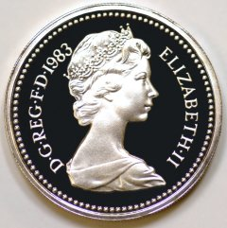

Money problems

Totals and change:

- How much altogether is 5p, 10p and 2p?

- Malachi spends 8p. How much change does he get from 20p?

- Roza spent 6p on toffees and 5p on fudge. How much change from 20p?

- Mohamed bought a bouncy ball for 8p and a sticker for 5p.
How much change from 20p?

- Jessica had 20p. She spent 8p. How much money does she have left?

- Lollies cost 6p each. How much do 3 lollies cost?


WHICH COINS?

Which coins could you use to pay for these things?
Write the different combinations down.

7. Toffee chew 5p
8. Fudge 6p
9. Bouncy ball 7p
10. Sticker 8p
11. Ice cream 10p

If you have time!

How much would it cost to buy 2 of each of the things above?
How much change from 20p?

Money Word Problems
At the fair.

- The big dipper costs 75p per ride. How much for two rides?

- Rosie and Tom pay 90p each to go on the ghost train. How much in total?

- Ali and Jo buy two ice creams at 99p each. How much in total?

How much change from £2.00?

- Mum buys Parveen and Preeti some candyfloss.
Parveen wants a large one for 55p. Preeti will have small one for 35p.

How much does Mum pay?
How much change does she get from £1.00?

- Sam has a 50p coin and two 20p coins.
She pays 70p to go on the helter skelter.
How much money does she have left?

- Fasal has a £1.00, a 20p and a 10p.
He pays 90p to go on the dodgems.
How much money does he have left?

- Dad buys 3 donuts at 70p each.
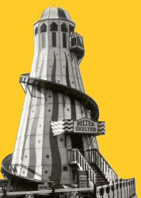
How much change does he get from £3.00?

- Tom buys 2 hotdogs at 40p each. He buys Mum a bar of chocolate for 35p.
How much money does he spend?
How much change from £2.00?

Money Word Problems

- Alishia wants to buy a £4.70 book and a £6.10 game.
How much will it cost her?

- It costs 80p for a child to swim.
How much does it cost for 6 children to swim?

- A jigsaw costs 65p. How many can you buy for £2.00?
How much change would you get?

- A CD costs £4.00.
Kareem saves 40p a week. How many weeks must he save
to buy the CD?

- Joe has three 50p coins and three 20p coins.
He pays 50p for a big dipper ride. How much does he have left?

- Lewis bought 3 computer games at £5.68 each. What was his change from £20?

- A chocolate bar costs 19p. How many bars can be bought for £5?

- Isaiah offered two silver coins to pay for a 14p pencil. Investigate how much change he could have got?



